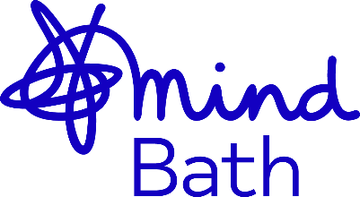

Event Volunteer
Team: Fundraising Team
Responsible to: Becki Fox, Fundraising Manager
Hours: Variable
About Us
Bath Mind are a local and independent mental health charity working across Bath & North East Somerset. While we are affiliated to the national Mind charity, we receive no direct funding from the national charity and work independently to develop our own services that suit local needs.
Established in 1998 by a group of people with lived experience of mental illness, we work tirelessly to provide support, information, advice, and activities for individuals in our community. We are in contact with thousands of individuals annually to support them with a greater understanding of their mental health, focusing both on preventing mental ill health and improving mental wellbeing.
Role Description:
We are looking for individuals who have an interest in event management and fundraising. In this role you will be working along the Bath Mind fundraising team to help run in-person fundraising events and campaigns across BaNES. This is a varied role which will include some evening and weekend work.
Benefits:
- You will gain valuable experience in event management and fundraising
- You will get the opportunity to meet and connect with like-minded people
- You will be contributing to a meaningful cause and helping to improve mental health awareness and support services across BaNES
Key Responsibilities:
- Assist with setting up events
- Help with attendee registration and check in
- Provide information and assistance as necessary
- Distribute event materials such as brochures, programs and promotional items
- Ensure all health and safety protocols are followed, including emergency procedures
- Report any incidents to the event manager promptly
- Help manage the collection of donations and pro-actively collect donations
- Provide a positive and welcoming atmosphere for all guests and participants
Desirable skills:
- Friendly and approachable with some customer facing experience
- Punctual and dependable
- Ability to work flexibility and adapt to different tasks
- Willingness to work collaboratively with staff and other volunteers
Our Inclusive Recruitment Commitment:
Bath Mind is committed to encouraging equality, diversity, and inclusion (EDI) throughout our entire workforce. The aim is for our workforce to represent the diverse society we live in, and that our employees, volunteers, and clients feel respected and heard by Bath Mind.
Bath Mind is growing to fulfil our ongoing commitment in inclusion in the workplace. As an organisation that prioritises the mental health and wellbeing of all, we are determined to create meaningful and lasting equitable change across our charity.
If you feel you are a great match for the volunteer opportunity, but do not feel you meet all of the criteria, we welcome you to submit an application.
How to apply:
If you are interested in an event volunteer role, please fill out our volunteer application form or contact the fundraising team at fundraising@bathmind.org.uk.

